**4.3 Statistical Analysis**

1. **Player Performance Evaluation**

# Calculate goals per match

players['Goals_per_match'] = players['goals'] / players['games']

# Display top scorers based on goals per match

top_scorers = players.sort_values(by='Goals_per_match', ascending=False).head(10)

top_scorers[['player', 'Goals_per_match']]

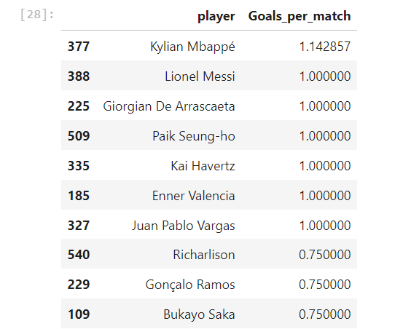

1. **Predicting Match Outcomes**

# Since matches have no result we use a proxy for Match_Result based on goals

# This is a simplified approach to adjust it as needed for our data.

teams['Match_Result'] = (teams['goals'] > teams['goals'].mean()).astype(int)

from sklearn.model_selection import train_test_split

from sklearn.linear_model import LogisticRegression

from sklearn.metrics import accuracy_score

# Calculate Pass Accuracy

teams['Pass_Accuracy'] = (teams['passes_completed'] / teams['passes']) * 100

# Prepare data for training

features = teams[['goals', 'possession', 'Pass_Accuracy']]

labels = teams['Match_Result']

# Split data

X_train, X_test, y_train, y_test = train_test_split(features, labels, test_size=0.2, random_state=42)

# Train the model

model = LogisticRegression()

model.fit(X_train, y_train)

# Test the model

predictions = model.predict(X_test)

print("Accuracy:", accuracy_score(y_test, predictions))

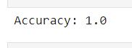

1. **Improved Tactical Understanding**

from sklearn.cluster import KMeans

import matplotlib.pyplot as plt

# Calculate Pass Accuracy

teams['Pass_Accuracy'] = (teams['passes_completed'] / teams['passes']) * 100

# Apply clustering (excluding Goals_Conceded if not available)

kmeans = KMeans(n_clusters=4, random_state=0).fit(teams[['possession', 'Pass_Accuracy']])

teams['Play_Style'] = kmeans.labels_

# Visualize clusters

plt.scatter(teams['possession'], teams['Pass_Accuracy'], c=teams['Play_Style'], cmap='viridis')

plt.xlabel('Possession')

plt.ylabel('Pass Accuracy')

plt.colorbar(label='Play Style Cluster')

plt.show()

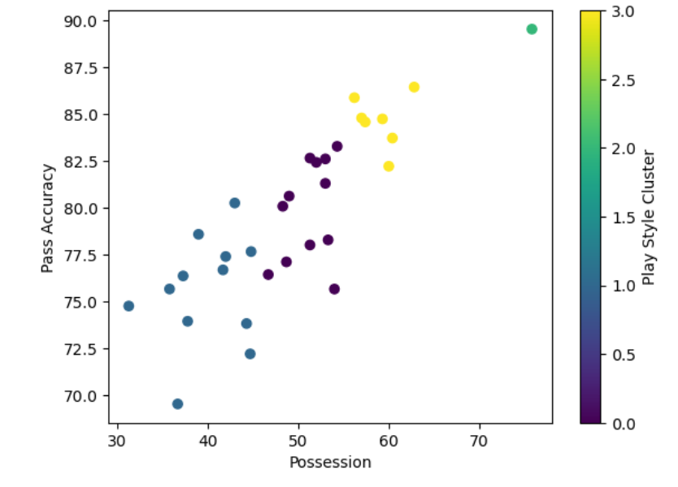

1. **Team Management and Player Selection**

# Check players with position as 'Forward'

forwards = players[players['position'] == 'FW']

print("Total forwards:", len(forwards))

# Check players with Goals per Match greater than 0.3

high_scorers = players[players['Goals_per_match'] > 0.3]

print("Total high scorers:", len(high_scorers))

# Try a lower threshold for Goals per Match

selected_players = players[(players['position'] == 'FW') & (players['Goals_per_match'] > 0.1)]

selected_players = selected_players.sort_values(by='Goals_per_match', ascending=False).head(3)

print(selected_players[['player', 'Goals_per_match']])

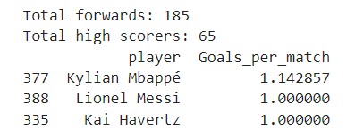

1. **World Cup Wins Analysis**

# Count the number of World Cups each country has won

world_cup_wins = world_cups['Winner'].value_counts()

print(world_cup_wins)

# Plot world cup wins

world_cup_wins.plot(kind='bar', title="World Cup Wins by Country")

plt.xlabel("Country")

plt.ylabel("World Cups Won")

plt.show()

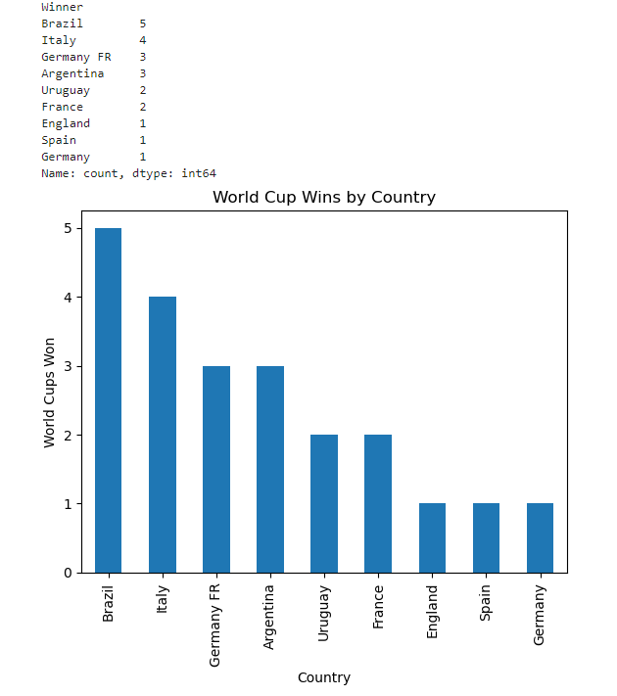

**4.4 Implementation**

**Fetch**

**import statements**

import pandas as pd

import numpy as np

import matplotlib.pyplot as plt

**Load the data**

players = pd.read_csv("player_stats.csv")

teams = pd.read_csv("team_data.csv")

world_cups = pd.read_csv("world_cups.csv")

**Display basic info**

print(players.head())

print(teams.head())

print(world_cups.head())

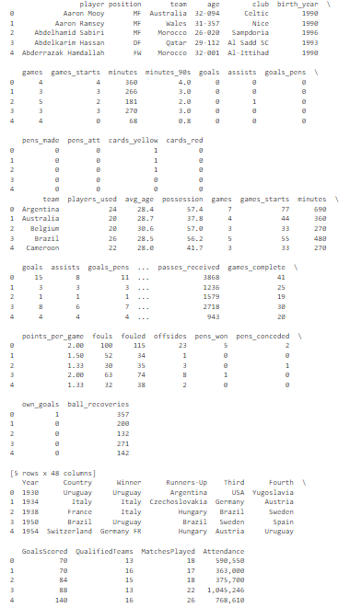

**Check for missing values and handle them**

players.fillna(0, inplace=True)

teams.fillna(0, inplace=True)

world_cups.fillna(0, inplace=True)

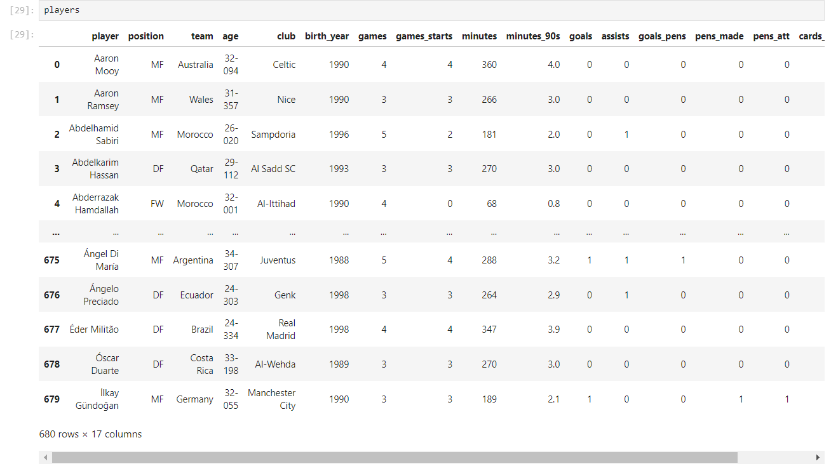

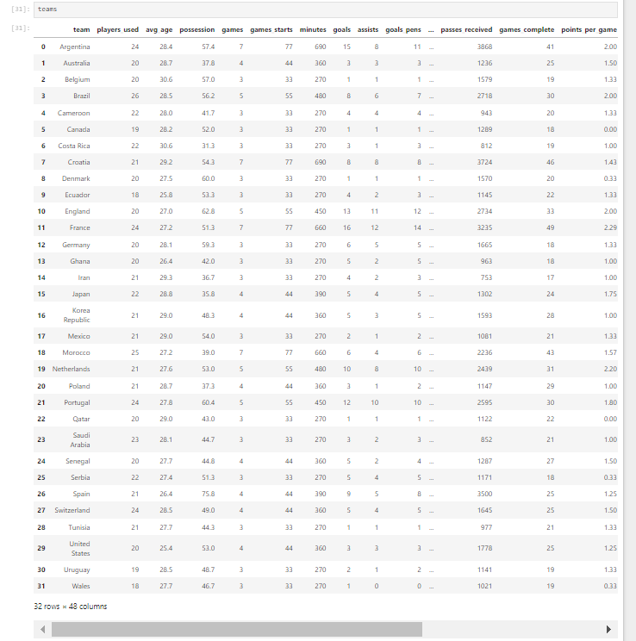

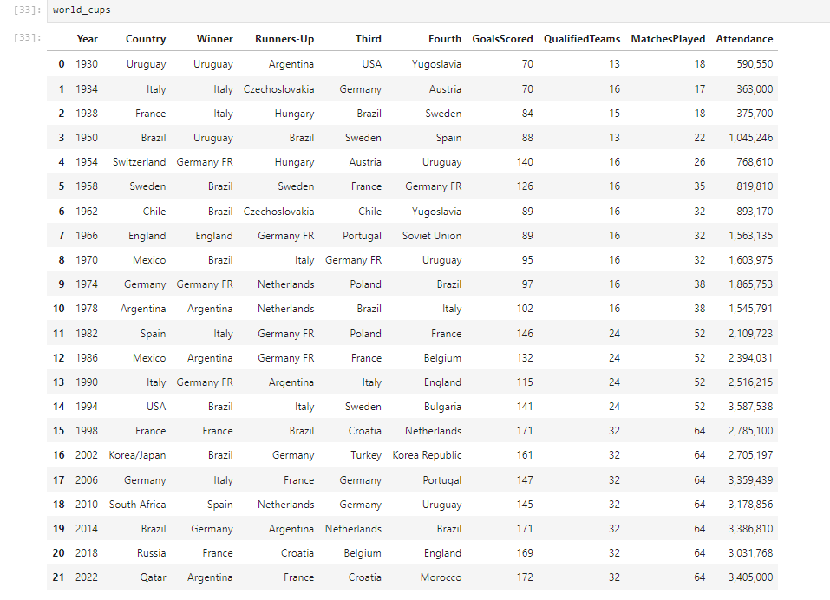

**Information of Each Data Sets**

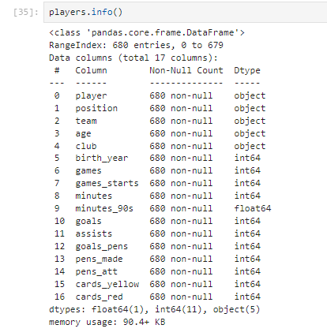

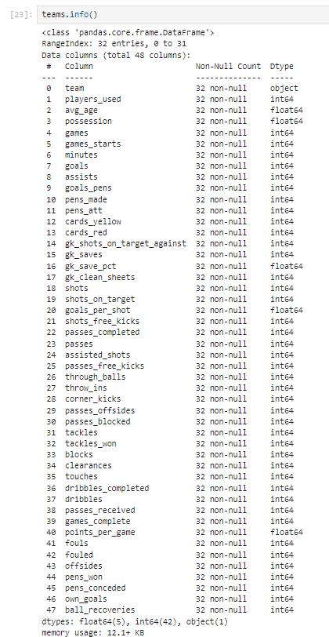

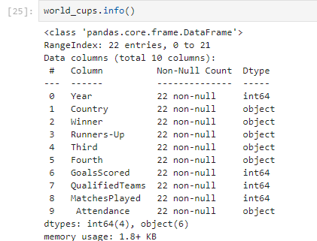

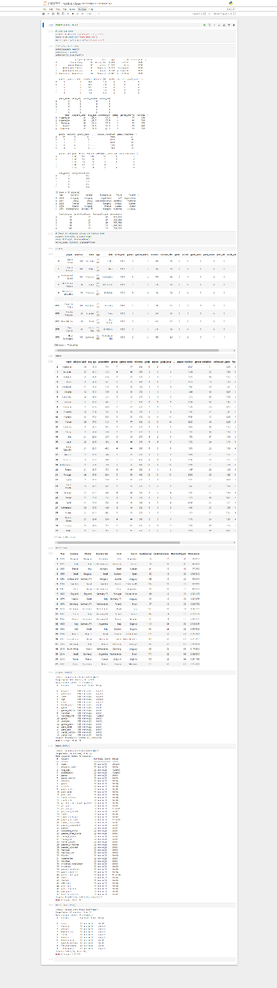**Fetch & Clean – Full Page Screenshot 🡪4.5 Data Visualization**

import pandas as pd

import matplotlib.pyplot as plt

import seaborn as sns

**1. Player Performance Comparison**

# Plot for Top Players by Goals per Match

plt.figure(figsize=(12, 6))

sns.barplot(data=top_scorers, x='player', y='Goals_per_match', color='skyblue')

plt.xticks(rotation=45, ha="right")

plt.title("Top Players by Goals per Match")

plt.xlabel("Player")

plt.ylabel("Goals per Match")

plt.show()

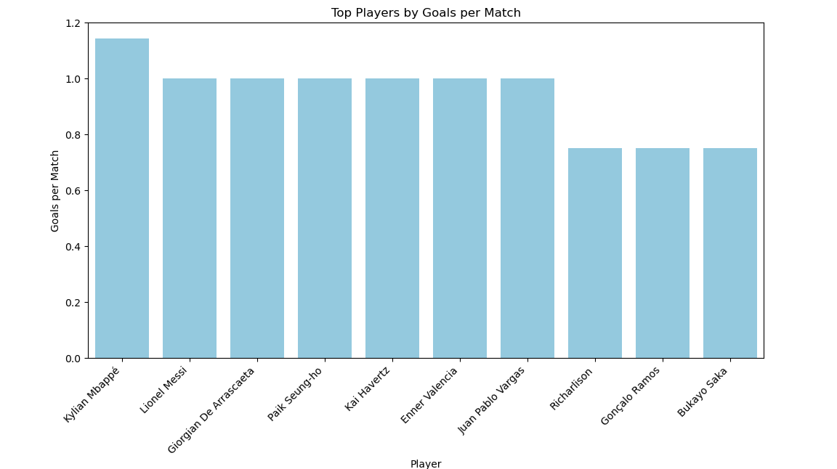

**2. Team Performance**

top_teams = teams[['team', 'goals']].sort_values(by='goals', ascending=False).head(10)

plt.figure(figsize=(12, 6))

sns.barplot(data=top_teams, x='team', y='goals', palette='viridis')

plt.xticks(rotation=45, ha="right")

plt.title('Top 10 Teams by Goals Scored')

plt.xlabel('Team')

plt.ylabel('Goals Scored')

plt.show()

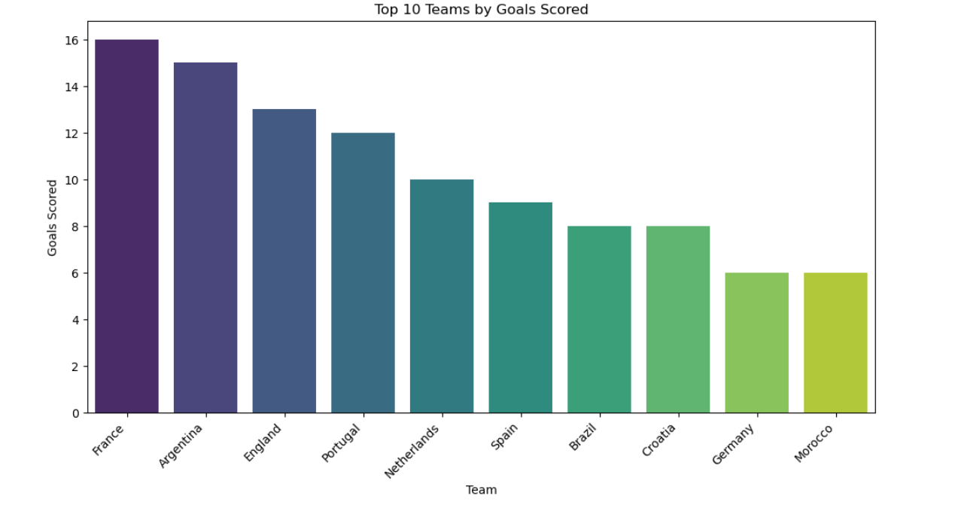

**3. World Cup Wins by Country (Bar Chart)**

plt.figure(figsize=(10, 6))

world_cup_wins.plot(kind='bar', color='gold')

plt.title("World Cup Wins by Country")

plt.xlabel("Country")

plt.ylabel("Number of World Cups Won")

plt.show()

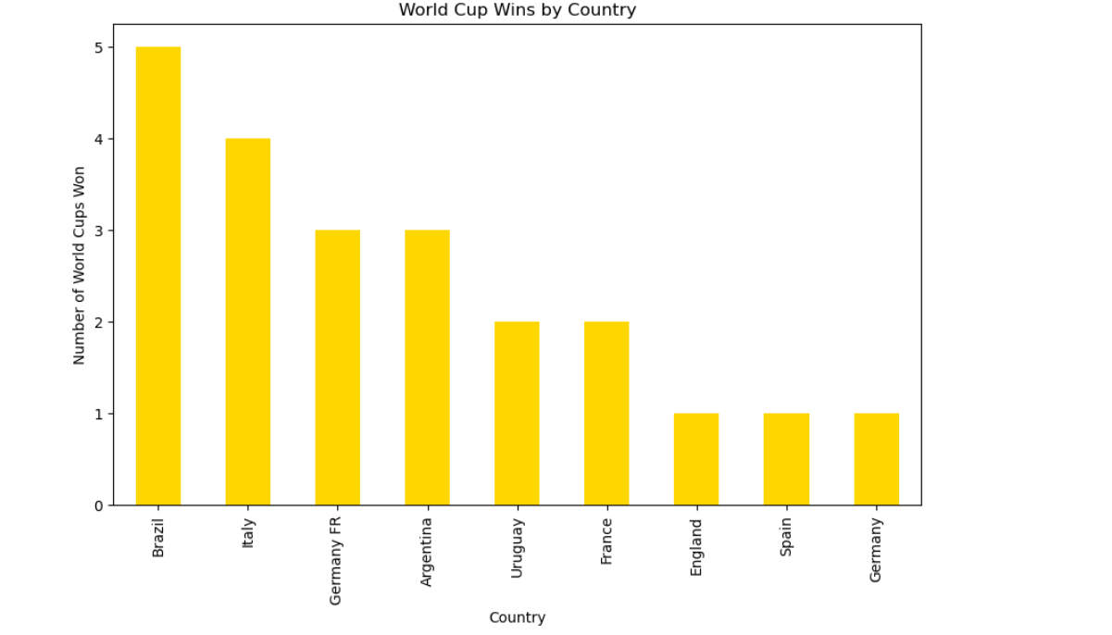

**4. Team Play Styles (Clustering Result)**

# Calculate Pass Accuracy if not already calculated

teams['Pass_Accuracy'] = (teams['passes_completed'] / teams['passes']) * 100

plt.figure(figsize=(12, 8))

sns.scatterplot(data=teams, x='possession', y='Pass_Accuracy', hue='Play_Style', palette='viridis', s=100)

plt.title("Team Clustering Based on Play Style")

plt.xlabel("Possession (%)")

plt.ylabel("Pass Accuracy (%)")

plt.legend(title='Play Style')

plt.show()

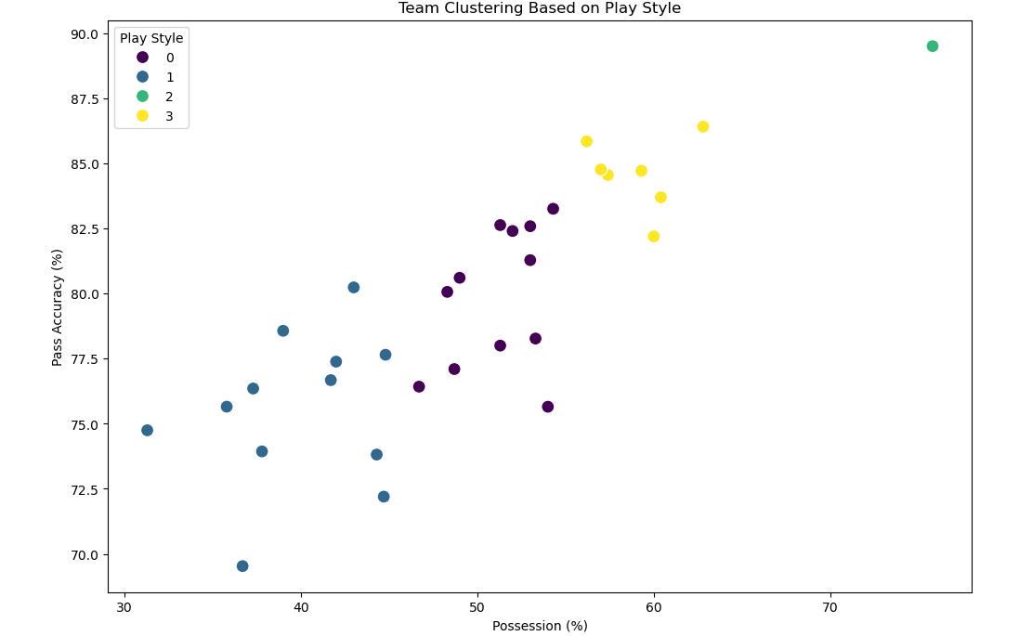

**5. Correlation Heatmap for Player Stats**

plt.figure(figsize=(10, 8))

correlation_matrix = players[['goals', 'assists', 'games', 'minutes', 'Goals_per_match']].corr()

sns.heatmap(correlation_matrix, annot=True, cmap='coolwarm')

plt.title("Correlation Heatmap of Player Stats")

plt.show()

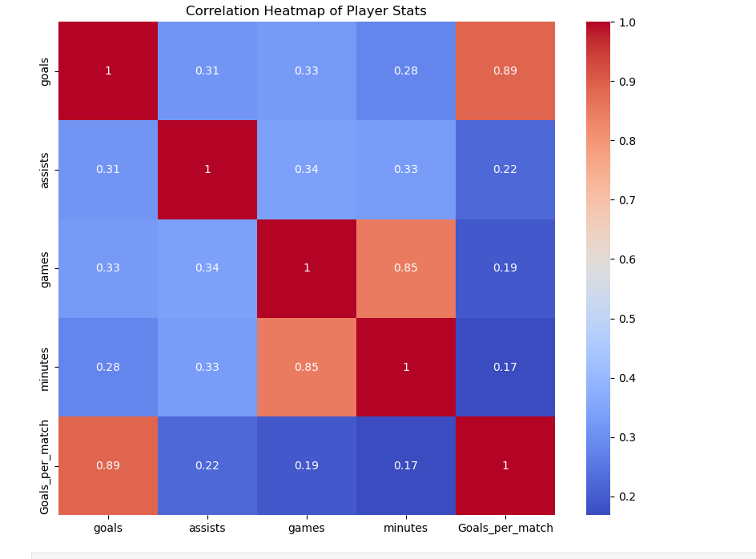

**4.6 Model Development and Evolution**

**Step 1: Predicting Player Performance (Goals Prediction)**

from sklearn.model_selection import train_test_split

from sklearn.linear_model import LinearRegression

from sklearn.metrics import mean_squared_error, r2_score

# Selecting features

X = players[['minutes', 'games', 'assists']]

y = players['goals']

# Split data

X_train, X_test, y_train, y_test = train_test_split(X, y, test_size=0.2, random_state=42)

# Model training

model = LinearRegression()

model.fit(X_train, y_train)

# Predictions

y_pred = model.predict(X_test)

# Evaluation

mse = mean_squared_error(y_test, y_pred)

r2 = r2_score(y_test, y_pred)

print(f'Mean Squared Error: {mse:.2f}')

print(f'R² Score: {r2:.2f}')



**Step 2: Clustering Players by Play Style**

from sklearn.cluster import KMeans

import matplotlib.pyplot as plt

import seaborn as sns

# Selecting features for clustering

features = players[['goals', 'assists', 'games', 'minutes']]

kmeans = KMeans(n_clusters=3, random_state=42)

players['Play_Style'] = kmeans.fit_predict(features)

# Visualizing clusters

plt.figure(figsize=(10, 6))

sns.scatterplot(data=players, x='games', y='goals', hue='Play_Style', palette='viridis')

plt.title("Clustering Players by Performance")

plt.show()

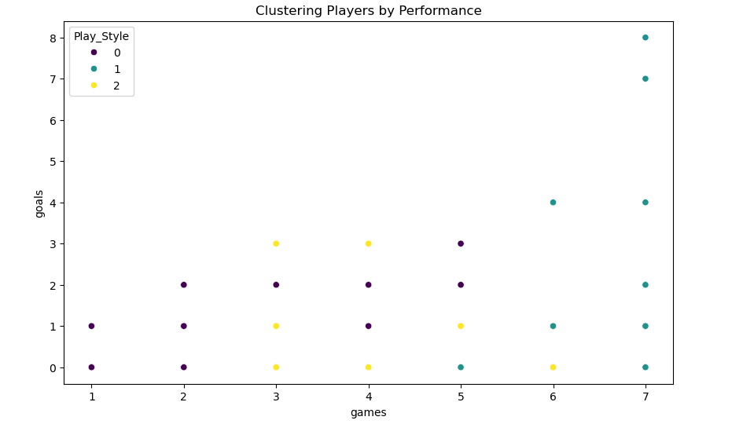

**1. KMeans Clustering: Grouping Teams by Play Style**

from sklearn.cluster import KMeans

import matplotlib.pyplot as plt

import seaborn as sns

import pandas as pd

# Calculate Pass Accuracy if not already calculated

teams['Pass_Accuracy'] = (teams['passes_completed'] / teams['passes']) * 100

# Select relevant features for clustering

team_features = teams[['possession', 'Pass_Accuracy', 'goals']]

# Initialize and fit KMeans

kmeans = KMeans(n_clusters=4, random_state=42)

teams['Play_Style'] = kmeans.fit_predict(team_features)

# Plot the clustering results

plt.figure(figsize=(12, 8))

sns.scatterplot(data=teams, x='possession', y='Pass_Accuracy', hue='Play_Style', palette='viridis', s=100)

plt.title("KMeans Clustering: Team Play Style")

plt.xlabel("Possession (%)")

plt.ylabel("Pass Accuracy (%)")

plt.legend(title='Play Style Cluster')

plt.show()

# View cluster centers to analyze the play styles

print("Cluster Centers:")

print(pd.DataFrame(kmeans.cluster_centers_, columns=team_features.columns))

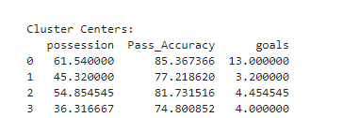

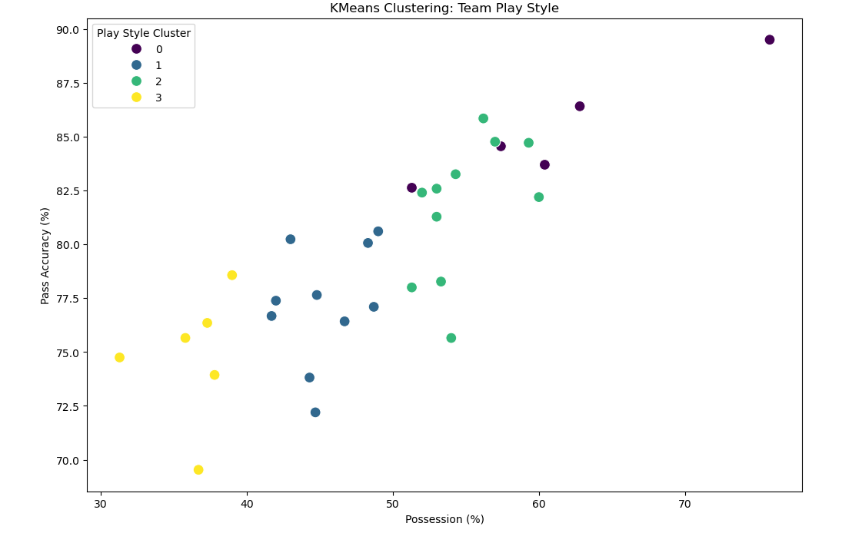

from sklearn.cluster import KMeans

from sklearn.metrics import silhouette_score

teams['Pass_Accuracy'] = (teams['passes_completed'] / teams['passes']) * 100

# Perform clustering with KMeans

kmeans = KMeans(n_clusters=4, random_state=42)

teams['Play_Style'] = kmeans.fit_predict(teams[['possession', 'Pass_Accuracy', 'goals']])

# Calculate Silhouette Score

silhouette_avg = silhouette_score(teams[['possession', 'Pass_Accuracy', 'goals']], kmeans.labels_)

print("Silhouette Score for KMeans Clustering:", silhouette_avg)



**2. K-Nearest Neighbors (KNN): Predicting Match Outcomes**

from sklearn.model_selection import train_test_split

from sklearn.neighbors import KNeighborsClassifier

from sklearn.metrics import accuracy_score, classification_report, ConfusionMatrixDisplay

import matplotlib.pyplot as plt

# Calculate Pass Accuracy if not already calculated

teams['Pass_Accuracy'] = (teams['passes_completed'] / teams['passes']) * 100

# Create a basic rule for Match_Result

teams['Match_Result'] = teams['goals'].apply(lambda x: 1 if x > 1 else 0)

# Prepare features and labels

features = teams[['goals', 'possession', 'Pass_Accuracy']]

labels = teams['Match_Result'] # 1 for Win, 0 for Loss/Draw

# Split data

X_train, X_test, y_train, y_test = train_test_split(features, labels, test_size=0.2, random_state=42)

# Initialize and train KNN model

knn = KNeighborsClassifier(n_neighbors=5) # Using k=5

knn.fit(X_train, y_train)

# Make predictions and evaluate

y_pred = knn.predict(X_test)

print("KNN Accuracy:", accuracy_score(y_test, y_pred))

print("\nClassification Report:\n", classification_report(y_test, y_pred))

# Plot Confusion Matrix

ConfusionMatrixDisplay.from_predictions(y_test, y_pred, display_labels=['Loss/Draw', 'Win'])

plt.title("KNN Match Outcome Prediction - Confusion Matrix")

plt.show()



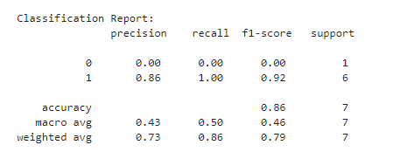

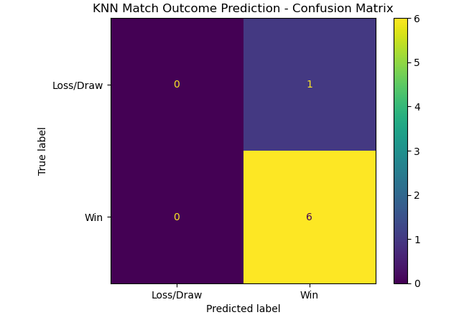

**3. Principal Component Analysis (PCA) for Dimensionality Reduction**

from sklearn.decomposition import PCA

from sklearn.preprocessing import StandardScaler

scaler = StandardScaler()

team_features_scaled = scaler.fit_transform(team_features)

# Apply PCA

pca = PCA(n_components=2)

principal_components = pca.fit_transform(team_features_scaled)

teams['PCA1'], teams['PCA2'] = principal_components[:, 0], principal_components[:, 1]

plt.figure(figsize=(10, 8))

sns.scatterplot(data=teams, x='PCA1', y='PCA2', hue='Play_Style', palette='Set2', s=100)

plt.title("PCA of Team Play Styles")

plt.xlabel("Principal Component 1")

plt.ylabel("Principal Component 2")

plt.legend(title='Play Style Cluster')

plt.show()

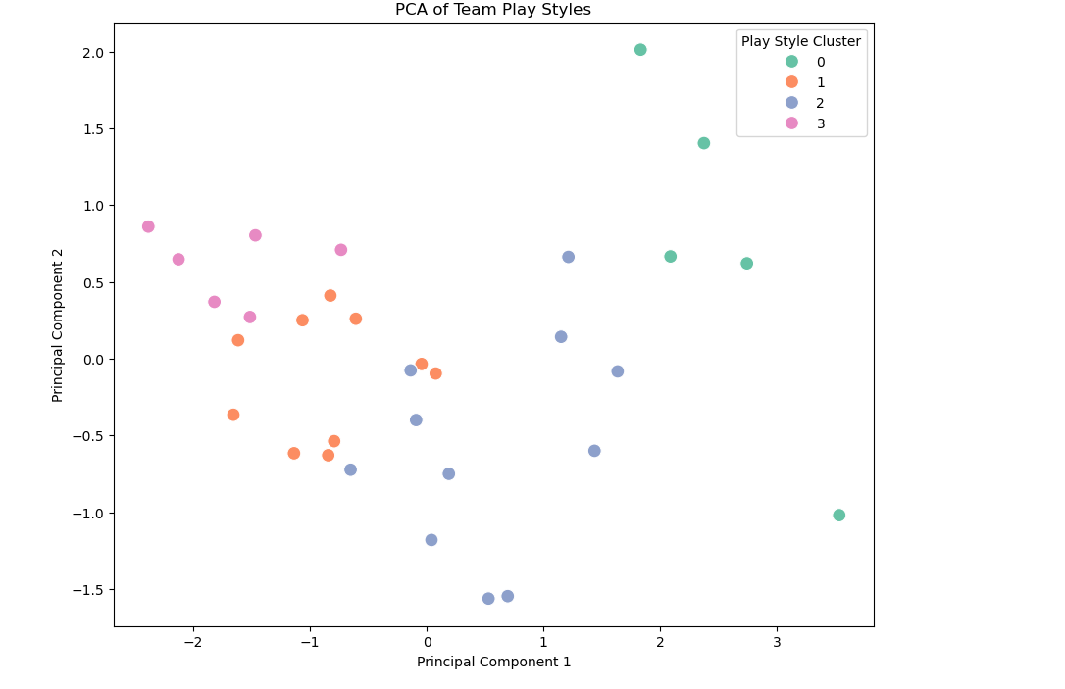

**4. Predicting Player Performance using Linear Regression**

from sklearn.linear_model import LinearRegression

from sklearn.metrics import mean_squared_error, r2_score

import matplotlib.pyplot as plt

from sklearn.model_selection import train_test_split

# Calculate Goals per Match if not already calculated

players['Goals_per_match'] = players['goals'] / players['games']

# Define features and target (without Tackles)

player_features = players[['minutes', 'assists']] # Adjusting for available columns

target = players['Goals_per_match']

# Split data

X_train, X_test, y_train, y_test = train_test_split(player_features, target, test_size=0.2, random_state=42)

# Train Linear Regression model

regressor = LinearRegression()

regressor.fit(X_train, y_train)

# Predict and evaluate

y_pred = regressor.predict(X_test)

print("Mean Squared Error:", mean_squared_error(y_test, y_pred))

print("R^2 Score:", r2_score(y_test, y_pred))

# Plot Actual vs Predicted values

plt.figure(figsize=(10, 6))

plt.scatter(y_test, y_pred, alpha=0.7, color="blue")

plt.xlabel("Actual Goals per Match")

plt.ylabel("Predicted Goals per Match")

plt.title("Linear Regression: Actual vs Predicted Goals per Match")

plt.show()



